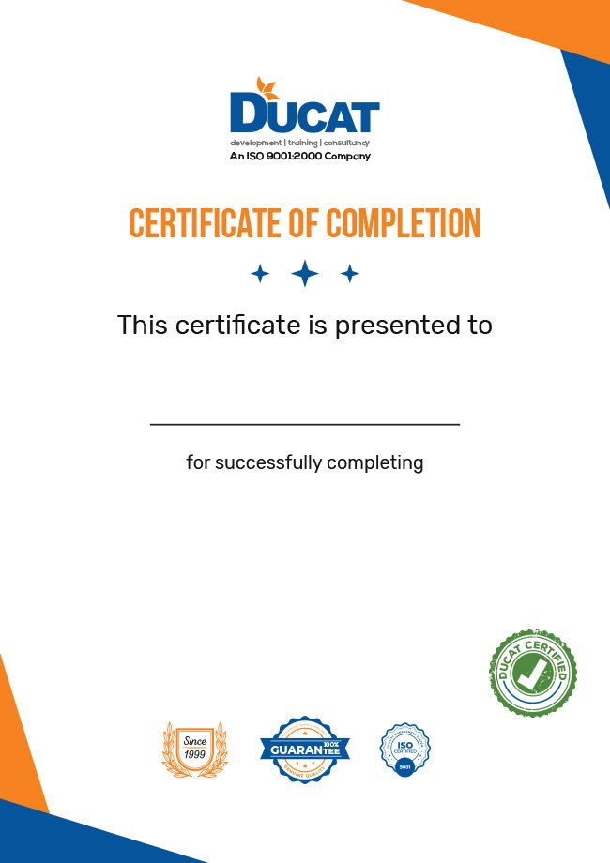
Aaliya Mehar
AWS DEVOPS ARCHITECT
Certificate Number: 301120227221702
Student ID: 25751
Course Start Date: 18/08/2022
Course End Date: 27/11/2022

